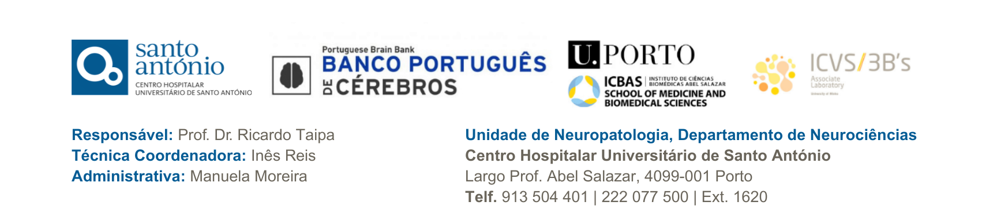



Supplementary Tissue Request Form

Please note: This form is for applying for the use of supplementary tissue as described in your original tissue request. If you plan on using this tissue for a different study you will need to reapply under a new tissue request.
To enable Portuguese Brain Bank to consider the release of further tissue for use in your project, please complete the form below:
Tissue Request Number –
Name and contact details –

Details of extra tissue requested (number of cases, amount, tissue state etc)

Reasons for requesting further tissue

Please return the completed form to ptbrainbank@chporto.min-saude.pt
If the request is considered appropriate, Portuguese Brain Bank will despatch further tissues as soon as possible.
If you have any queries regarding this form please contact either:
Prof. Dr. Ricardo Taipa – rtaipa.neuropat@chporto.min-saude.pt
Inês Reis - inescaladoreis@chporto.min-saude.pt

